Chara Kolokytha

Aristide [Joseph Bonaventure] Maillol (1861-1944)

Aristide Maillol was a French sculptor, painter, designer, engraver and illustrator. Maillol studied painting under Jean-Léon Gerôme and Alexandre Cabanel at the École des Beaux Arts and was largely influenced by August Renoir, Paul Gauguin and the École de Pont Aven, as well as ancient Greek and Roman sculpture. From 1895 he became a self-taught sculptor and continued to sculpt until the end of his life.

Maillol’s sculpture is distinguished by the timeless classicism, calmness, sensuality and idealistic symbolism that marked the course and outcome of the twentieth century classical revival in twentieth century France. Nonetheless, his work cannot be identified with academicism. Together with Charles Despiau he is considered to be one of the most representative artists of the French neo-classical tradition. Maillol’s work exerted considerable influence over the development of modernist aesthetics in France between the wars and it was largely appreciated in Germany by artists such as Georg Kolbe and Rudolf Belling, and by Henri Moore in Britain.

Maillol’s sculpture was based on specific themes such as female nudes (Seated figure, 1930), Venuses (Vénus au collier, 1928) and mythic figures (Les Trois Nymphes, 1930-8). The work demonstrates an idealised conception of natural forms that obtain symbolic value since they are attached to universal ideas, such as femininity, rather than material themes. In 1902, Maillol completed his first major work resulting in wide recognition. La Méditerranée (1902) was presented at the 1905 Salon d’Automne and was prized for the sobriety and elegance that became the trademark of his overall sculptural production. Subsequently, he was commissioned to model several public monuments in France, with the most important being the Cezanne Memorial (stone, Musée d’Orsay) which was rejected in 1925 by the town of Aix-en-Provence, a fact that reveals the modernist aspirations of his style.

Maillol also worked as an illustrator creating a large number of woodcuts for Virgil’s Eclogues (1910), Longus’ Daphnis and Chloe (1937) and Paul Verlaine’s Chansons pour Elle (1939). In 1939, he elaborated a double page colour lithograph with two nude Sirens for the cover of Verve magazine, edited by Tériade.

Films

Aristide Maillol sculptor, directed by Jean Lods 1942. (French).
The artist and his model, directed by Fernando Trueba, 2012 (French) http://elartistaylamodelo.com/es/home/

List of works

Seated figure, 1930, terracotta, MoMA, N. Y.

Vénus au collier (Venus with necklase), 1928, bronze, Tate Gallery, London.

Les Trois Nymphes (Three Nymphs), 1930-8, lead, Tate Gallery, London.

La Méditerranée (The Mediterranean), bronze, 1902, MoMA, N.Y.

References and further reading

Denis, M. (1925) Aristide Maillol, Paris, Crès.

Zervos, Ch. (1925) Aristide Maillol, Paris, Albert Morancé.

Cladel, J. (1937) Aristide Maillol, sa vie, son œuvre, ses idées, Paris, B. Grasset.

Charbonneaux, J. (1948) Maillol, Paris, Braun.

Chevalier, D. (1970) Maillol, N. Y., Crown.

Kramer, L. (2000) Aristide Maillol (1861-1944): Pioneer of Modern Sculpture, Thesis, New York University.

Lorquin, B. (2002) Aristide Maillol, Genève, Skira.

Wilhelm Lehmbruck, Aristide Maillol: Exhibition of Sculpture (2013) N. Y., Museum of Modern Art.

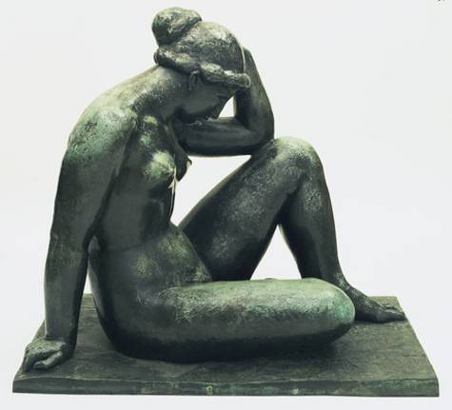

Maillol, The Mediterranean, Bronze, MoMA.

